**COMMENTS AND SUGGESTIONS FOR THE HEMP4WATER PROJECT**

**By D. Duayne Whitehurst**

**May 21, 2020**

**Background**

My interest in finding uses for industrial hemp has a long and convoluted history.

During the summer of 1956, between my graduation from Peoria Central High School and my freshman year at Bradley University, I had the opportunity to work on a research project at the USDA National Center for Agricultural Utilization Research: Peoria**,** IL**.** The group I participated in was New Crops with a goal of identifying new crops that could be cultivated using conventional farm equipment and could be replacements for crops that were being overproduced.

That study included evaluation of kenaf, *Hibiscus cannabinus*, for use as a fiber for paper manufacture. It was found that the kenaf could generate fibers that could be converted into an exceptional quality paper. This was due to a low quantity of five carbon sugars in the cellulose.

By a strange serendipity I am now interested in a relative of kenaf, industrial hemp, as a means to sequester the nutrients in Florida’s fresh waters and prevent the formation of red tide in the Gulf of Mexico. The industrial hemp thus produced must have commercial use. Unfortunately, if all of the nutrients were to be sequestered, the yield of biomass could be larger than can be accommodated by the need for fibers as I will describe below.

In another life, I have been involved in research for 43 years devoted to the production of alternative fuels by conversion of coal and biomass and have authored books and scientific papers on this subject. That work has been honored by several awards and invitations to consult for DOE and several industrial companies on the fundamental science of such transformations. The bottom line is that such conversions are only economic if conducted by simple reactions. Recently pyrolysis of biomass followed by hydrogenative upgrading is being studied throughout the world. I suggest that hydroponic industrial hemp may be an important source of biomass for this application.

**Comments on the Heard Poster and Other Relevant Publications**

The poster by J. Heard et.al.1,2 is very interesting and quite thorough. Much of the data presented is relevant to the present Hemp4Water project3. However there are several substantial differences between that study, conducted on land, and the proposed hydroponic cultivation of industrial hemp as a means to sequester nutrients from fresh water sources.

* One significant difference is that the harvesting will be quite different. Harvesting on land leaves the root and some stalk in the ground that is eventually reused in subsequent plantings. Hydroponic procedures will harvest the entire plant. Thus the yields of biomass will be greater than those reported by Heard. The overall consumptions of nutrients will also be greater.
* Another difference between the proposed project and that of Heard, is that the source of the nutrients necessary for plant growth will be undesired materials produced by runoff waters from various natural sources. Cultivation on land requires purchase of fertilizers for optimal crop growth.4,5,6
* A possible problem in hydroponic cultivation is the probable lack of symbiotic fungi, *Mycorrhizae*, necessary for phosphate incorporation into the plant roots.7,8
* Perhaps the greatest difference between hydroponic cultivation of hemp to sequester nutrients and cultivation of hemp to produce the greatest yields of fiber or seed, will be the optimal time for harvest. In Canada, only one crop per year is possible whereas in Florida, it may be possible to produce multiple crops per year (perhaps as many as than five, as I will discuss below).
* Cultivation on land has the advantage that hemp fibers are isolated on the same area as they are grown. The retting process separates the high quality bast fiber from the low quality hurd or shiv. It requires about 5 weeks. This is not a problem when only one crop per year is available. After retting the stalks have to be dried to less than 15% moisture before fiber isolation. This whole process yields only about 3.5% bast fibers. If hemp is grown hydroponically, additional landmass will be required for retting, drying and processing.9,10
* Seed production from hemp requires long maturation times, generally between 70 and 90 days and only yields about 7wt% seed.
* Optimization of nutrient sequestering may produce low quality fiber and little seed but could be an excellent source of biomass for producing biofuels. Several shorter growing cycles could be available to yield much more biomass per acre and extensive drying may not be required. This will be enumerated below.

**Interpretation of the Heard Data**

In order to understand the details presented in Heard’s poster1,2, the raw data had to be extracted from the reported graphs and several assumptions were necessary. It is common for agricultural literature to refer to the phosphorus content as P2O5 rather than atomic P which is only 43.64% of P2O5. Similarly, potassium concentration is commonly reported as K2O which is only 80.01% potassium. By contrast, nutrient concentrations reported in water analyses are on an atomic mass basis. Thus when comparing analyses from different sources the reported yields of P and K were converted to atomic masses.

Unfortunately, the raw data used to produce the poster was not available. As an alternative, the numerical data was extracted from the reported graphs by reading the values on the Y-axis and tabulating the individual concentrations. Rather than plot dates, the actual number of days of plant maturation were used. A summary of the tabulated data is shown in Tables 1-3.

**Table 1**

**Observed Biomass Yields**



**Table 2**

**Observed Nitrogen Yields in Pounds per Acre**



**Table 3**

**Observed Phosphorus Yields as P2O5 in Pounds per Acre**



From these data, the % N and P in each plant constituent were calculated at each period of growth as shown in Tables 4 and 5.

**Table 4**

**Observed %N in Each Component**



**Table 5**

**Observed %P in Each Component**



In the Heard poster “Dry Matter Accumulation” graph, it appeared that after August 24 (day 84), the total yield of dry matter declined. This is also shown in the revised data from Table 1 (see Figure 1).

**Figure 1**

**Observed Yields of Dry Matter**

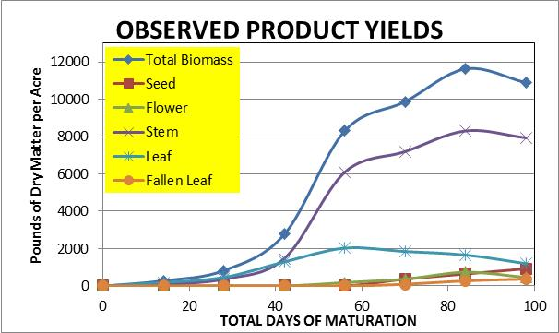

It is clear that the yield of leaves declines as the plants mature and there is an indication that some loss of yield of stalk also occurs. The yields are reported on a dry mass basis so one wonders how this happens.

Another way to present the data may help to explain this dilemma. Figure 2 shows some component yields plotted against the total yield that occurred at the various stages of maturation. Plotted in this way the products should exhibit a smooth progression of each individual yield increasing as a function of the summed yields. However the data appear to be erratic.

**Figure 2**

**Individual Components as a Function of the Total Biomass Yield**

One possible explanation for the strange appearance of the component yields could be that the overall production of total biomass was actually higher than that observed. As all data were reported on a dry mass basis, loss of moisture could not be the explanation. A more reasonable conclusion could be that fallen leaves suffered significant biodegradation so they were under reported.

If one assumes that fallen leaves are biodegraded, then the observed yields would appear low. Following this assumption, the yields of fallen leaves and total biomass were modified to provide plots that looked more reasonable. Compare Figures 3 and 4. The yield of stem also appeared to be slightly low, so this was adjusted as well. The adjusted values used in subsequent discussions are presented in Table 6.

**Figure 3 Figure 4**



**Table 6**

**Yields of Biomass and Plant Constituents Adjusted for Biodagredation (lbs/Acre)**



Adjusting the biomass and fallen leaf values required recalculation of the potential yields of sequestered nitrogen and phosphorus. In these calculations, the fallen leaf concentrations of N and P were assumed to be the same as those of the normal leafs.

The recalculated yields are presented in Tables 7 and 8.

**Table 7**

**Adjusted Yields of Sequestered Nitrogen in Plant Constituents (Lbs/Acre)**

|  |  |  |  |  |  |  |  |  |
| --- | --- | --- | --- | --- | --- | --- | --- | --- |
| DATE | 6/1/18 | 6/15/2018 | 6/29/18 | 7/13/18 | 7/27/18 | 8/10/18 | 8/24/18 | 9/7/18 |
| DAYS | 0 | 14 | 28 | 42 | 56 | 70 | 84 | 98 |
| TOTAL N Yield | 0 | 15 | 34 | 85 | 183 | 193 | 199 | 204 |
| Calc Total N | 0 | 15 | 34 | 85 | 179 | 183 | 184 | 191 |
| Seed N Yield | 0 | 0 | 0 | 0 | 0 | 9 | 15 | 34 |
| Flower N Yield | 0 | 0 | 0 | 0 | 10 | 15 | 25 | 15 |
| Stem N Yield | 0 | 3 | 9 | 33 | 84 | 79 | 76 | 74 |
| Fallen Leaf N Yield | 0 | 0 | 0 | 0 | 0 | 7 | 20 | 36 |
| Leaf N Yield | 0 | 12 | 25 | 52 | 85 | 73 | 47 | 33 |
| Sum Leaf + Fallen | 0 | 12 | 25 | 52 | 85 | 80 | 68 | 68 |

**Table 8**

**Adjusted Yields of Sequestered Phosphorus in Plant Constituents (lbs/Acre)**

|  |  |  |  |  |  |  |  |  |
| --- | --- | --- | --- | --- | --- | --- | --- | --- |
| DATE | 6/1/18 | 6/15/2018 | 6/29/18 | 7/13/18 | 7/27/18 | 8/10/18 | 8/24/18 | 9/7/18 |
| DAYS | 0 | 14 | 28 | 42 | 56 | 70 | 84 | 98 |
| TOTAL P2O5 Yield | 0 | 2.8 | 6.6 | 18.1 | 39.4 | 44.0 | 49.3 | 54.0 |
| Seed P2O5 Yield | 0 | 0.0 | 0.0 | 0.0 | 0.0 | 4.9 | 9.7 | 16.7 |
| Flower P2O5 Yield | 0 | 0.0 | 0.0 | 0.0 | 3.8 | 3.8 | 4.9 | 3.5 |
| Stem P2O5 Yield | 0 | 0.3 | 2.1 | 8.7 | 19.8 | 19.4 | 18.4 | 14.1 |
| Fallen Leaf P2O5 Yield | 0 | 0.0 | 0.0 | 0.0 | 0.0 | 1.2 | 3.5 | 7.1 |
| Leaf P2O5 Yield | 0 | 2.4 | 4.5 | 9.4 | 14.9 | 12.2 | 8.2 | 6.6 |
| Sum Leaf+Fallen P2O5 | 0 | 2.4 | 4.5 | 9.4 | 14.9 | 13.4 | 11.7 | 13.7 |

**Missing Yields**

As mentioned above, some losses of sequestered nutrients occurs as leaves fall from the stalk and biodegradation occurs. This is common practice in cultivation of industrial hemp where harvested stalks, seeds and retted nonfibrous materials are plowed back into the soil. Roots are also not recovered. In hydroponic cultivation, the entire plant may be harvested so biomass yields could be significantly greater than field planted hemp.

It has been reported that hemp plants consist of a constant proportion of above ground/below ground ratio of 5.46 and the N content is 1.31%.11 I could not find the P content of hemp root, but if it is similar to other plant roots, it should be around 0.1%. In future studies, it would be useful to determine the actual values for total root yields, root %N and root %P.

Assuming the literature values are correct, then the root biomass would be 2522 lbs/acre and the total biomass yield in Heard’s study would be 16291lbs/acre. The total N and P incorporated could possibly be higher by 33 and 16 lbs/acre respectively.

**Sequestration of Nutrients With Increasing Maturation**

The goal of the Hemp4Water project is to determine the potential for hydroponic industrial hemp to remove nutrients from Florida’s fresh water resources. The following discussion addresses some key features of such a process based on Heard’s studies and some relevant literature. Not knowing the absolute yield of root biomass or the % N or %P in the roots, this contribution was not included in these discussions.

By separating the individual yields and N and P contents, it is possible to trace the progress of N and P incorporation into the various components reported by Heard. Figures 5 and 6 illustrate how nitrogen is incorporated into the growing hemp as the plant matures.

Figure 5 Figure 6



It is interesting to note that the incorporation of N reaches a maximum in about 60 days and there is a systematic progression of N from stalk and seed to flower and then to seed. The values for fallen leaves are only predicted values for the case where the fallen leaves would be harvested prior to biodegradation.

Figures 7 and 8 show similar behaviors for phosphorus as the plants mature and exhibit similar trends. One difference between N and P is that sequestering of phosphorus increases as seeds are produced while sequestered nitrogen is lost.

**Figure 7 Figure 8**



**Potential of Industrial Hemp for Sequestering Nutrients in Florida’s Fresh Water Resources**

Heard’s poster1,2 provides an excellent background for assessing the potential of hydroponic cultivation of industrial hemp for sequestering unwanted nutrients in Florida’s fresh water resources. The mass balance for input and output of biomass, N and P are summarized in Table 9. Note the yields of phosphorus are presented as atomic P. Values in the table include calculations from reported values and estimates for potential yields from hydroponic cultivation. Discussions will concentrate on the reported data.

**Table 9**

**Mass Balance of Nutrients provided in Fertilizers and Yields in Crop Products**

|  |  |  |  |
| --- | --- | --- | --- |
| **NUTRIENT/COMPONENT** | **INPUT**  **(pounds/acre)** | **OUTPUT (pounds/acre)** | **POTENTIAL**  **(pounds/acre)** |
| Total Biomass | 0 | 10892 | 16291 |
| Seed | 35 | 923 | 923 |
| Nitrogen | 16 | 180 | 213 |
| Phosphorus | 14 | 18 | 31 |
| Potassium | 108 | 103 |  |
| Sulfur | 10 | 13 |  |

It is surprising that 35 pounds of planted seeds can produce 10,892 pounds of harvested plant matter including 923 pounds of seed. When one considers the potential for nutrient removal, the nutrient supplied for plant growth is substantial but puzzling. Small increases were observed for P and S but the results demonstrate the appropriate application of fertilizer in this study. However N yield was considerably larger than the amount used in the original fertilizer. The potassium yield went through a maximum where 129 pounds of K were observed after 56 days of maturation before flowering or leaf loss commenced. Note the potassium requirement is much larger than that for phosphorus.

Two possible reasons for these observations can be considered. Heard’s study did not include analysis of the nutrient content of the soil prior to planting or the soil after the study. Thus some nutrient depletion in the soil could account for some of the observed increases of P and S yields. Another possible reason could be symbiotic nitrogen fixation from bacteria in the soil and/or *Mycorrhizae* fungus in combination with bacteria.8 Recall that the reported biomass yields did not include root, small amounts of stalk or biodegraded leaves.

If one assumes that hydroponic growth of hemp offers the same yield/time behavior as Heard’s reported

field data, then it is possible to estimate the balance between the influx of unwanted fresh water nutrients and sequestered nutrients by the plants.

There are several excellent references for the concentration of nutrients in Florida’s fresh waters and the volumetric flow rates of various locations.12- 17 Unfortunately the reported data vary widely from report to report and year to year. Each report presents the data in different units, which makes comparisons difficult. In Table 10, the data were recalculated so they could be compared on the same unit basis. Water flows are presented cubic feet/year, N and P values are presented in pounds per year.

**Table 10**

**Annual Water Flow Rates and Nutrient Loads for Okeechobee Influx at S-77**

|  |  |  |  |
| --- | --- | --- | --- |
| **Reference** | **Influx Rate**  **1010 Cubic Feet/Year** | **Nitrogen Load**  **106 Pounds/year** | **Phosphorus Load**  **106 Pounds/year** |
| 12 Table 6 | 3.79 | 2.48 | 0.105 |
| 12 Table 3 |  | 2.39 | 0.099 |
| 12 p15 regulatory | 8.20 |  |  |
| 13 Fig 6 |  |  | 0.503 |
| 14 Table p2 |  | 7.00 |  |
| 15 Table ES-1 | 1.47 | 1.31 | 0.129 |
| 16 Table 6.3-4 | 4.25 | 4.29 | 0.229 |

Annual flow rates and nutrient loads at S-79, the exit of the Caloosahatchee River are about 3 times larger.12-16 For the present discussion, only the situation at S-77 will be considered using the values reported in reference 12.

Considering first the nutrient contents along Caloosahatchee Waterway, a map of the various locations is presented in Figure 9, taken from reference 12,

**Figure 9**

**The Caloosahatchee River Watershed**

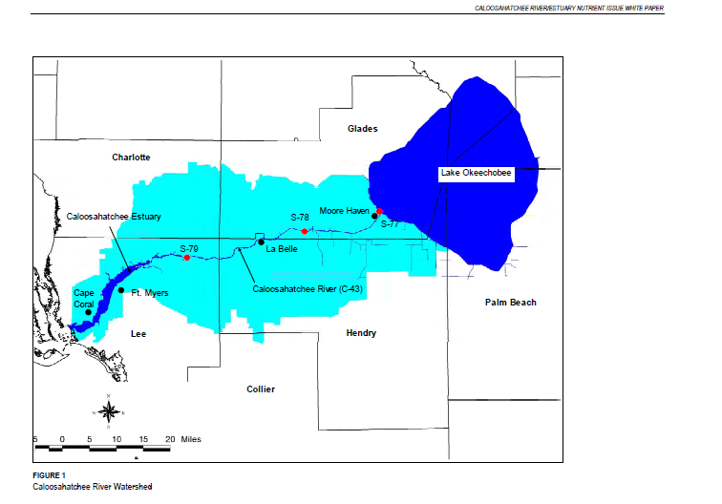

Figure 10, shows the progression of nutrient concentrations from the exit of Lake Okeechobee (S-77) to the entrance of the Caloosahatchee Estuary (S-79). Units presented in this graph are expressed in pounds/year for ease in comparison to the yields shown in Table 9. 14  Cultivation areas may also be expressed as square miles. The conversion factors used in subsequent discussions are the following.

1acre = 0.0015625square miles 160acres = 0.25 square miles

1hectaer = 2.47105 acres = 0.00386102 square miles

1 metric ton = 2200 pounds

1 acre-foot = 43559.9 cubic feet

1mg/l = 1 part per million weight = 1000 parts per billion weight

1cubic foot/sec = 0.00316x1010 cubic feet/year

**Figure 10**

**Nutrient Influx into the Caloosahatchee Waterway**

When considering a location for nutrient sequestering it should be noted that this profile is not smooth. Figure 11 shows that there are two major nutrient sources into this waterway so removal of nutrients may require two sites.

**Figure 11**

**Individual Nutrient Influxes into the Caloosahatchee Waterway**

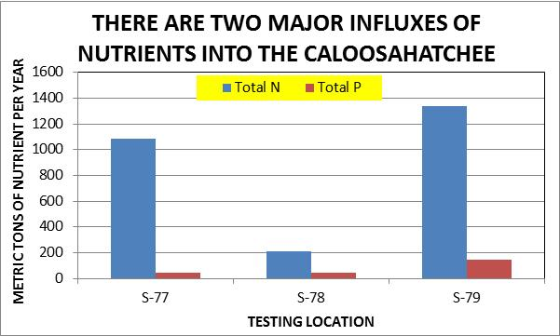

Phosphorus may be the most important nutrient to remove if some microbe fixes atmospheric nitrogen in the waters, thus regenerating the nutrient contamination. The sources of phosphorus that enter the southern Florida watershed are well described in reference 13.

An illustration of these sources is taken from reference 13 and presented in Figure 12.

**Figure 12**

**Nutrient Concentrations in Ground Water are Highly Variable13**

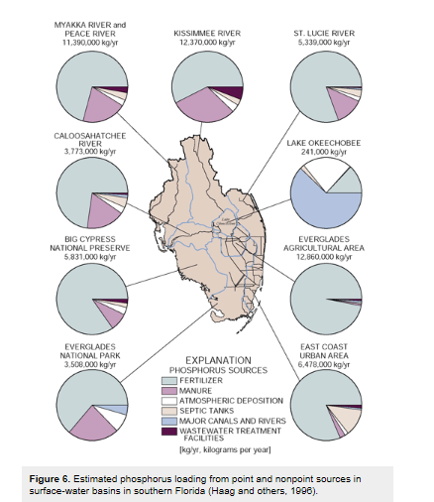

Considering first the possible sequestration of nutrients at the exit of Lake Okeechobee into the Caloosahatchee Waterway, the quantity of total N and P nutrients that would have to be sequestered is 2.48 and 0.105 million pounds per year respectively. Heard reported a cultivation period of 98 days and required 160 acres in order to remove 25,760 and 6832 pounds of N and P respectively.

If one 98 day cultivation cycle is considered, the amount of N that should be sequestered is 1,152,367 pounds and that of P should be 61,703 pounds. To balance the amount supplied and amount sequestered the cultivation area would have to be 11.2 square miles for 100% of the nitrogen and 2.3 square miles for 100% of the phosphorus.

If the hemp were to be harvested in 60 days, before flowering and leaf loss, the areas required for cultivation could be lowered. The yield of sequestered N would be higher (28657 pounds) and the yield of P would be slightly lower (6167 pounds). So the required cultivation areas to remove 100% of the N and P would be 6.2 and 1.5 square miles respectively.

At first glance these scenarios seem feasible. However, the fresh water flow rates must also be considered. The average discharge rate of Lake Okeechobee at S-77 is 734 cubic feet/second.12 That results in 3.81 billion cubic feet of water in 60 days and 6.21 billion cubic feet of water in 98 days.

An area of 6.2 square miles filled with water to a depth of one foot would represent a volume of only 0.173 billion cubic feet. So such an area would be sufficient to accommodate the average influx of water from Lake Okeechobee.

The regulatory release of water during rainy seasons at S-77 is 2600 cubic feet/second, so the cultivation areas would have to be 3.5 times larger but still may be feasible. But where would such areas be found? Lake Okeechobee’s area is 730 square miles so partitioning off 6.2 square miles may be possible but larger areas could be problematic. Location of a cultivation area within the Caloosahatchee Waterway is not feasible as the large area required would impede boat traffic.

An alternative could be to identify a wetland area that water exiting Lake Okeechobee could be diverted to a reservoir adjacent to the Caloosahatchee Waterway where water cleanup by sequestering nutrients with hydroponic hemp cultivation could be conducted. Lake Hicpochee is a potential candidate. It is presently a wetland swamp on the Caloosahatchee Canal. Figure 13 shows the location and Figure 14 presents a satellite blowup of the wetland area. The yellow oval indicates an area that would be 11 square miles, which is in line with the desired area for hydroponic cultivation.

Presently there is a project in the Hicpochee Wetland (Lake Hicpochee Shallow Storage and Hydrologic Enhancement Project) that is under construction, with a goal of providing additional storage of water from the Caloosahatchee River and to improve the water quality in the downstream canal. This project could be a match with the Hemp4Water project.

**Figure 13**

**Lake Hicpochee is Wetland Swamp on the Caloosahatchee Waterway**

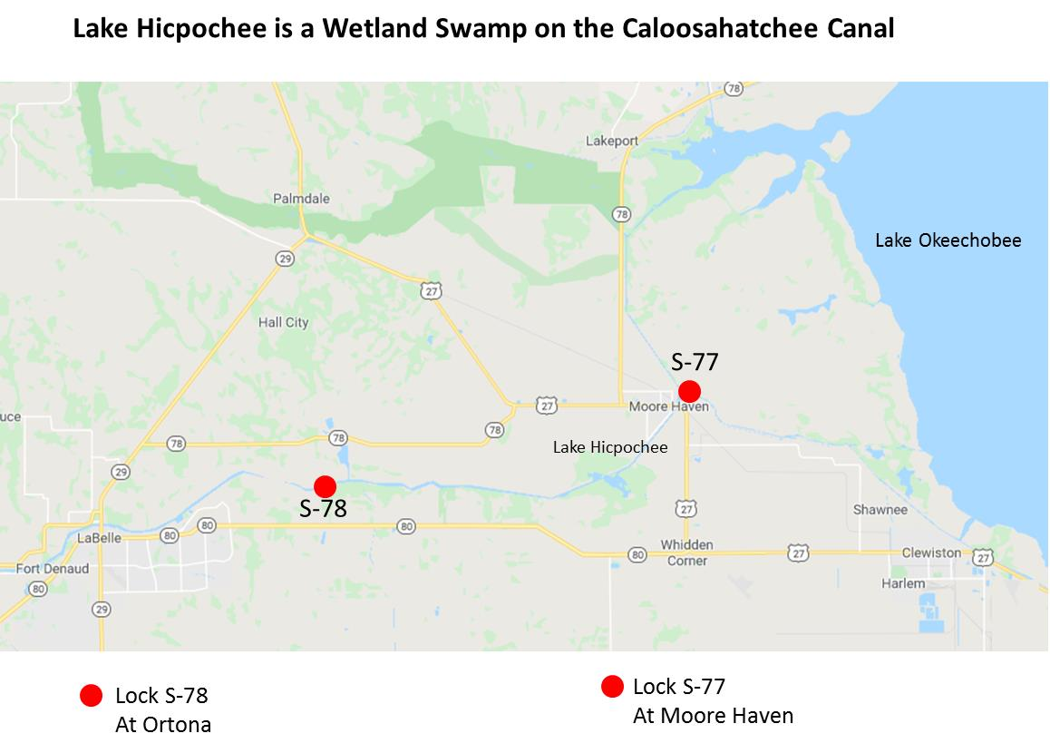

**Figure 14**

**Lake Hicpochee Wetland Area**

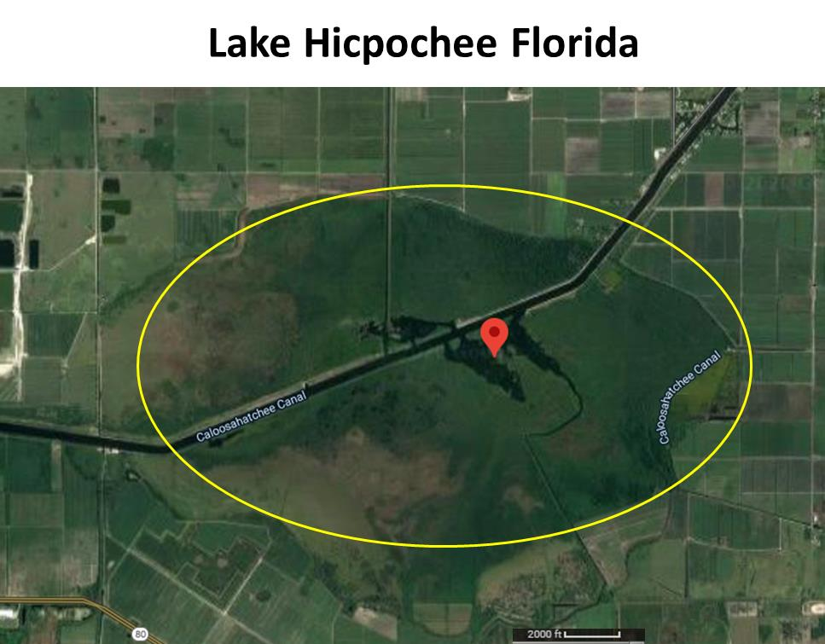

**Utilization of the Biomass Produced by Hydroponic Cultivation of Industrial Hemp**

One goal of hydroponic cultivation of industrial hemp is to remove nutrients from Lake Okeechobee and the Caloosahatchee Waterway. This would reduce the growth of toxic freshwater algae and inhibit the formation of red tide in the Gulf of Mexico. Such reductions would be a great benefit to the health of Floridians17 and to Florida’s tourist industry. The question remains: how would the produced biomass be utilized?

If the nutrients were to be completely removed near S-77 or S-70, there would be a huge volume of biomass that would result. The stoichiometric yields of biomass for complete removal of nutrients in a single growing cycle is shown in Table 11.

**Table 11**

**Yield of Biomass in a Single Growing Cycle**

|  |  |  |
| --- | --- | --- |
| Location | 60 days @ 6.2mi3 | 98 days @ 11.2mi3 |
| S-77 | 3968 metric tons | 7168 metric tons |
| S-79 | 9600 metric tons | 17300 metric tons |

However, unlike the Canadian study, Florida has a climate that would allow cultivation of more than one crop per year. This would be desirable in order to remove nutrients throughout the entire year. For example five 60 day cycles could yield about 20,000 Metric tons of biomass per year. If 60 day cycles are to be considered, then the product biomass would not include any seed and only low quality fiber for conventional hemp utilization. Finding a market for such quantities of low value fibers seems unreasonable.

Some studies have been done on biodiesel production from hemp seed, but the yield of seed is low and cultivation times are long. Biodiesel produced in this way has been said19 to be competitive with other seed crops such as soybean, sunflower, peanut or rapeseed but overall the productivity is quite low. Typically hemp seed contains 30% oil and it has been estimated that the yield of biodiesel from industrial hemp would be about 300 gallons of biodiesel per acre.19 This may be slightly optimistic. Heard’s study observed a seed yield of only about 6.7% and required 98 days of maturation. So in the 6 sq mi scenario above, the yield of oil would only be about 1100 barrels of oil (compared to reference 19 estimate of 1300 barrels). The maturation required 98 days to provide that yield. Figure 1 shows that no seed is produced in the first 60 days of cultivation so fewer cultivation cycles would be possible if 98 days were required for seed production.

Enzymatic hydrolysis of hemp stalk followed by fermentation to produce ethanol and/or methanol has been suggested,19 but this route is quite involved and would be expensive.

By contrast, there are numerous studies throughout the world on the conversion of biomass to biofuels. The most economic conversion for low value biomass such as hemp is pyrolysis.20-23 Common biomass starting materials include wood, grass, peat, crop stalks, leaves and municipal solid waste. Pyrolysis of industrial hemp has been investigated in the past23 but has not been considered as a byproduct of nutrient removal.

Typically, biomass pyrolysis consists of several sequential and parallel reactions, as shown in Figure 15. This illustration is taken from reference 22.

**Figure 15**

**Typical Reactions that Occur During Pyrolysis of Biomass**

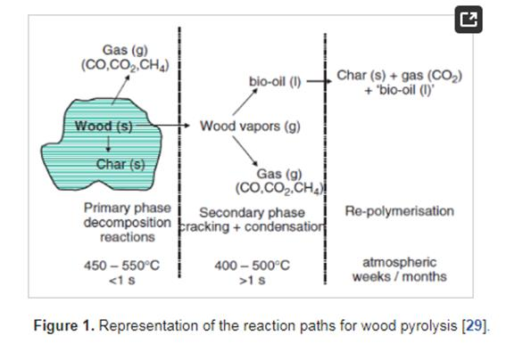

Typical product yields reported in reference 22 are reproduced in Figure 16.

**Figure 16**

**Yield Distribution From Biomass Pyrolysis**

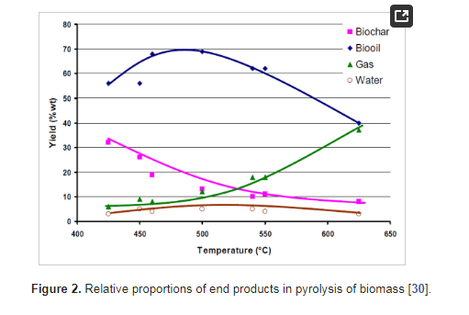

The actual yields depend greatly on the pyrolysis procedure and oil yields can vary widely as shown below.22

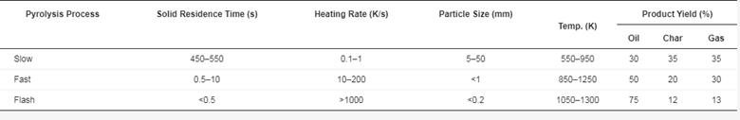

Further, the typical pyrolysis oils contain 6 to 8% oxygen, about 0.4% nitrogen and high ppm levels of phosphorus.22,24  Such compositions are not acceptable in marketable diesel fuels and substantial upgrading by catalytic hydroprocessing is required. The high N and P levels in typical biomass pyrolysis oils present major obstacles in upgrading because of severe catalyst deactivation.24

Some recent research has found that a modified pyrolysis procedure can produce oils which contain significantly lower amounts of nitrogen and less char byproduct.24 A key to this improvement is the presence of catalytic amounts of alkali metal salts in the plant matter. Potassium is an exceptional catalyst and Heard reported that the potassium content of growing hemp maximizes at around 60 days maturation.3 So shorter cultivation cycles could be beneficial in this application.

The scale of combined nutrient sequestration with harvested biomass pyrolysis could provide an economically favorable co-process. Reported studies for converting rice hulls to fuel showed that economics became favorable as the plant capacity increased beyond 10 tons per day as illustrated in Figure 14.22 As discussed above, the biomass yield in 60day cultivation cycles would be in the order of 10 tons per day. At 50% yield each 60 day cycle would produce 15,000 barrels of diesel fuel.

**Figure 14**

**Conversion of Rice Hulls by Pyrolysis and Upgrading Becomes Economic at Large Scale22**

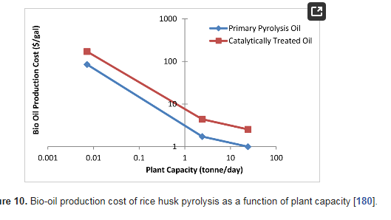

**Summary**

There appears to be a reasonable potential for combining nutrient sequestration from Florida’s contaminated fresh water resources with pyrolysis/upgrading of the produced biomass to marketable fuels. Hydroponic cultivation of industrial hemp for this application is a viable candidate for such a combined process.

**References**

1. <http://www.umanitoba.ca/faculties/afs/MAC_proceedings/proceedings/2007/Heard_poster.pdf>
2. <http://www.hemptrade.ca/eguide/production/nutrient-use>
3. <http://www.southflorida.edu/news/sfsc-partners-with-hemp4water-to-research-the-removal-of-contaminants-from-floridas-rivers-and-lakes>
4. <https://npketc.soils.wisc.edu/2018/05/02/fertility-guidelines-for-hemp-in-wisconsin/>
5. <https://acsess.onlinelibrary.wiley.com/doi/epdf/10.2134/cftm2015.0159>
6. <https://www.researchgate.net/publication/225616342_Characterisation_of_hemp_Cannabis_sativa_L_roots_under_different_growing_conditions>
7. <https://mycorrhizae.com/how-it-works/>
8. <https://link.springer.com/article/10.1007/BF00933493>
9. <https://extension.psu.edu/industrial-hemp-production>
10. <https://hempgazette.com/industrial-hemp/hemp-fiber-production/>
11. <https://www.researchgate.net/publication/225616342_Characterisation_of_hemp_Cannabis_sativa_L_roots_under_different_growing_conditions>
12. <http://crca.caloosahatchee.org/crca_docs/Caloosahatchee_Nutrient_Draft.pdf>
13. <https://pubs.usgs.gov/circ/circ1207/major_findings.htm>
14. <https://floridadep.gov/sites/default/files/caloosa-estuary-bmap-final-nov12.pdf>
15. <https://www.floridaocean.org/sites/default/files/documents/PDFS/Water%20Quality%20Assessment%20of%20the%20SLRW%20-%20Water%20Year%202017.pdf>
16. <https://www.sfwmd.gov/sites/default/files/documents/ne_crwpp_main_123108.pdf>
17. <https://www.ncbi.nlm.nih.gov/pmc/articles/PMC2968748/>
18. <http://gannettfleming.com/Projects/2018/08/21/07/34/lake-hicpochee-shallow-storage-and-hydrologic-enhancement>
19. <http://www.fibrealternatives.com/hemp%20is%20the%20ultimate%20cash%20crop_byWmConde.pdf>
20. <https://www.sciencedirect.com/science/article/abs/pii/S209549561830901X>
21. <https://www.researchgate.net/publication/315921754_Experimental_analysis_about_the_exploitation_of_industrial_hemp_Cannabis_sativa_in_pyrolysis>
22. <https://www.mdpi.com/1996-1073/5/12/4952/htm>
23. <https://www.sciencedirect.com/topics/engineering/catalytic-pyrolysis>
24. D.D. Whitehurst, personal experience.